TYPE OF GRANTS:
Mini Grants – The Southington Education Foundation will award up to $500 to SPS educators for innovative and creative student learning experiences that expand existing educational opportunities. Suggested areas of focus (1) Digital Needs, (2) Diversifying Classroom Libraries and/or (3) STEAM. Other areas will be considered.

FUNDING GUIDELINES:
- Projects must align with the SEF mission as well as the goals and curriculum of the Southington Public Schools.
- The SEF will not fund programs or supplies traditionally funded by the Board of Education (BOE), fund an existing BOE program, or supplant programs traditionally funded by the BOE.
- Funds will not be awarded for multiple applications from an individual school to fund an entire program.
- The SEF will not fund compensation for substitute teachers, salaries, or stipends, or food.
- Proposals for new programs are preferred over repeat requests for an already awarded program.
- SEF will give preference to grants that impact the largest number of students.
- Grant applicants must to be involved in all stages of the project from planning through evaluation.
- All funded materials are the property of the Southington Public Schools.
- If for any reason a grant recipient is unable to administer the approved project, the grant recipient will return all allocated funds to the SEF.
- The Applicant must submit a Project Evaluation with copies of all receipts and invoices 30 days after project completion.
- The Building Principal must approve and sign the application.

GRANT SUBMISSION:
- The Applicant must answer all the questions on the application.
- TECHNOLOGY:
  - When technology is requested, applicants must obtain the approval of the SPS Director of Technology to ensure that all equipment and technical aspects of program are compatible with the school network/equipment and that chosen technology is the most suitable, and cost-effective means of carrying out the project. Please submit a letter from the SPS Director of Technology with your application stating this.
- Obtain district technology pricing from the SPS Director of Technology for inclusion in your budget.
- Consider the computing hardware currently available in your school before submitting a request for such equipment.
- Submit the application as a WORD document, not as a PDF. The cover page with the principal’s signature should be scanned and submitted separately as a PDF.
- Submit the application and any questions to: sef.inc.grants@gmail.com
- Please anticipate confirmation of receipt within one week of submission.

GRANT TIMELINES:
GRANT DUE DATE | NOTIFICATION OF AWARD/REJECTION
August 11, 2020 | September 9, 2020
September 15, 2020 | October 14, 2020
October 12, 2020 | November 11, 2020
November 17,2020 | December 16, 2020

Thank you for your interest and support of the SEF mission. Through creative and innovative learning experiences, student learning is enriched.

APPLICATION FOR MINI-GRANT FUNDING
The grant committee will use a “blind” review process in evaluating each proposal. In order to maintain the integrity of the process, DO NOT include the names of the applicants, schools, or other identifying features in the Grant Application found on the next page. Please submit a typed, complete application electronically to sef.inc.grants@gmail.com
AMOUNT OF FUNDING REQUEST
$500
PROJECT TITLE Windows & Mirrors

CONTACT PERSON(S) Lenore Butler | EMAIL lbutler@southingtonschools.org
SCHOOL: Strong

PRINCIPAL’S ENDORSEMENT:
As the building principal, I have reviewed this application. By signing this application, I indicate my support for the application and the project.

Melissa Barbuto
__________________________________________ _______________________________________________
Print Name Principal’s Signature

APPLICANT’S STATEMENT:
The information in this application is accurate. I understand that I will be required to submit a Project Evaluation with copies of all receipts and invoices 30 days after project completion. The Project Evaluation Form may be found on the SEF website on the Grants and Programs page.

Lenore Butler_____________________________________ _____________________________________
Print Name Applicant’s Signature

SOUTHINGTON EDUCATION FOUNDATION
Mini grant Application
Submit the application as a WORD document, not as a PDF. The cover page with the principal’s signature should be scanned and submitted separately as a PDF.
DIRECTIONS WHEN REQUESTING TECHNOLOGY:
- When technology is requested, applicants must gain approval of the SPS Director of Technology to ensure that all equipment and technical aspects of program are compatible with the school network/equipment and that chosen technology is the most suitable, and cost-effective means of carrying out the project. Please submit a letter from the SPS Director of Technology with your application stating this.
- Obtain district technology pricing from the SPS Director of Technology for inclusion in your budget.
- Consider the computing hardware currently available in your school before submitting a request for such equipment.

This Box is for Committee Use Only: Grant Number:

PROJECT TITLE:

AMOUNT OF FUNDING REQUESTED:

CHECK OFF AREA OF FOCUS: ____DIGITAL NEEDS
__x__DIVERSIFYING CLASSROOM LIBRARIES
____STEAM
____OTHER (list area: )

THIS PROJECT WILL BE FOR: _x___CLASSROOM USE
____DISTANCE LEARNING
____BOTH

NUMBER OF STUDENTS IMPACTED BY THIS GRANT: 17

GRADE LEVEL(S) OF STUDENTS IMPACTED BY THIS GRANT: grade 5

TIMELINE:
START DATE: March 2021
END DATE: June 2021

SUMMARY OF THE PROJECT: (Brief – one to two paragraphs)

This project will help students learn that stories can be like windows and mirrors. Reading and responding to stories that act as windows and mirrors can make students feel less alone, more connected to others in the world, understand others and build empathy.

The world looks different depending on who and where you are. Students need practice understanding multiple points of view. The study of texts that reflect their own identities, experiences and motivations act as mirrors. The study of texts that provide insight into the identities, experiences and motivations of others act as windows. These text studies can move students toward more nuanced perceptions of the world around them.

My classroom library includes many grade level appropriate texts that act as mirrors. This grant would help expand my library to include a collection of diverse books that would act as windows for my students.

The books will be used during read alouds, reading workshop, independent reading time, whole class reading, and book club books. Most importantly, rich discussions will take place about knowledge gleaned from reading these diverse texts.

MEASURABLE LEARNER OBJECTIVES: The Learner Objective(s) must be (1) specific, (2) measurable, (3) achievable, (4) realistic, and (5) timely. List assessment method(s) specifically.

SMART GOAL:
S - The learner will read and respond to at least 10 culturally diverse books that act as windows for
the reader.

M- The learner will keep a log of books read. During and after reading each book, the learner will
answer questions based on CCSS stated and linked below.
CCSS.ELA-LITERACY.RL.5.1
Quote accurately from a text when explaining what the text says explicitly and when drawing inferences from the text.
CCSS.ELA-LITERACY.RL.5.2
Determine a theme of a story, drama, or poem from details in the text, including how characters in a story or drama respond to challenges or how the speaker in a poem reflects upon a topic; summarize the text.
CCSS.ELA-LITERACY.RL.5.3
Compare and contrast two or more characters, settings, or events in a story or drama, drawing on specific details in the text (e.g., how characters interact).

A: Grade 5 ELA CCSS align easily with this work. It also meshes well with the STEPS Asset of the
month for January & February which is Cultural Diversity.

R: The learners are accustomed to reading and responding to literature as mirrors. They can pull
on that knowledge to read books that serve as windows.

T: This can be achieved by the end of the current school year. (June 2021)

STUDENT ACTIVITIES: Provide a list of specific student activities to be completed as part of this project.

- When students finish reading a book from our diverse book collection they will ‘Book Buzz” about the book as a way to highlight the “window” or “mirror” experience. Book Buzzes are a common procedure to share books in the reading workshop method of teaching reading.
- After reading a book, students will share how the book was either a window or a mirror for them. They will write about how it either made him/her feel connected and why, or how it helped him/her build understanding and/or empathy.
- These responses will be displayed on a hallway bulletin board on papers with either a window background or a mirror background in the text box. This bulletin board display will highlight the diverse texts that have been read and serve as a fun incentive for kids to increase the volume of reading they do.
- Students will also record these responses via the Flipgrid videos to share our reading experiences with each other and the wider school community and with the SEF.

EVALUATION: List the student data and/or student work product(s) which will be used to assess student learning/mastery of the objective(s). Samples of the data and/or work products will need to be presented to the Foundation at completion of the project.

The log and responses will be scored based on the Grade 5 CCSS learning progression rubrics from the grade 5 Interpretation Book Club unit from Columbia Teacher’s College Reading and Writing Project.

14/17 students are currently at a level 4 on this progression. 3/17 are at a level 5.

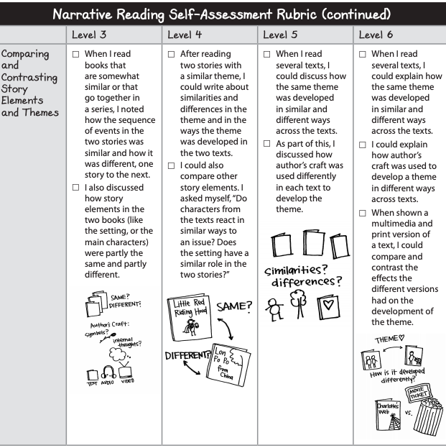

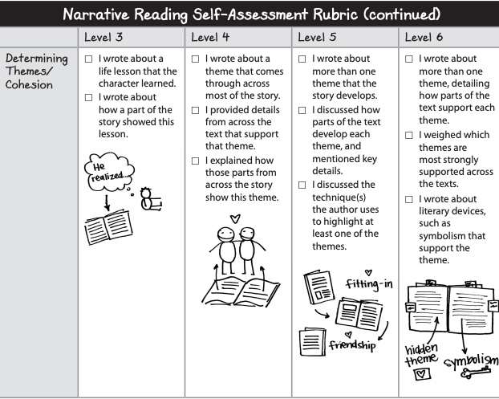

SUSTAINABILITY: Explain how the project will be sustained after funding from the Foundation ends
The books acquired through this grant will last for years to come.

BUDGET: Please complete the attached budget summary. Be specific and detailed. (Instructional materials, equipment, etc.)

This Box is For Committee Use Only: Grant Number:

Project Title: |  | Windows & Mirrors
Amount Requested: |  | $500
 |  | Start Date | End Date
Budget Period: |  | March 2021 | June 2021
Itemized Expenses:
List quantity, item name, cost per unit, total cost for quantity
Include shipping/handling costs
The SEF will not fund costs for food
Provide the TOTAL cost for all items at the bottom of the last column

Quantity | Item Name |  |  | Cost per Unit | Total Cost for item
20 | Front Desk |  |  | 5.50 | 110.00
5 | I am Malala: Young Reader’s Edition |  |  | 5.50 | 27.50
5 | Other Words for Home |  |  | 5.50 | 27.50
5 | The Unwanted: Stories of Syrian Refugees |  |  | 9.50 | 47.50
1 | A Hope More Powerful Than the Sea |  |  | 9.50 | 9.50
1 | Celebrate Diversity picture book pack |  |  | 17.50 | 17.50
5 | Ways to Make Sunshine |  |  | 4.50 | 22.50
1 | All Because You Matter |  |  | 13.50 | 13.50
1 | Binny’s Diwali |  |  | 13.50 | 13.50
5 | Ghost Boys |  |  | 7.50 | 37.50
5 | Roll of Thunder, Hear Me Cry |  |  | 5.50 | 27.50
5 | Three Keys |  |  | 5.50 | 27.50
5 | New Kid/Stargazing book duo |  |  | 16.50 | 82.50
5 | Blended |  |  | 6.50 | 32.50
5 | The Boy Who Harnessed the Wind |  |  | 5.50 | 27.50
Total |  |  |  |  | 499.00

Approved by the SEF Board of Directors 7.14.2020

